

Thurman “Tony” Smith - Senior Vice President and Territory Executive.

Tony recently took on the role as the division’s Territory Executive for the Midwestern United States. His imprint on underserved communities can be observed across the footprint where PNC is among the largest investors in CDFI’s like National Community Investment Fund, IFF and Community Investment Corp (Chicago). Under his leadership, the bank closed one its earliest Opportunity Zone workforce housing developments in Sheboygan, WI. In Chicago, his team was the lead investor on the New Market Tax Credit enabled Englewood Square, bring a grocer to a grocer desert, La Casa Norte’s supportive housing project in Humboldt Park, Esperanza Community Health Center in Brighton Park, the city’s first Opportunity Zone enabled development, Ogden Commons which houses Mt. Sinai’s community health practice in West Lawndale, XS Tennis in Bronzeville and the TIF enabled Local Market grocer in South Shore.

Through the pandemic, Tony co-authored and launched the bank’s PPP liquidity Facility program, which offered more than $70 million to CDFI to enable delivery of PPP loans to very small businesses. He also served as a co-chair of the Chicago Inclusionary Housing Task Force which was established to frame the city’s affordable housing policy. He sits on several boards, including the Cook County Land Bank Authority, Institute Capital (a North Carolina CDFI) and the University of Chicago Community Accelerator. He also served on the executive committee fof CIC, the Board of Directors of Benefit Chicago and the Board of NHS.

Most recently, he served a co-chair of the United Way of Metropolitan Chicago’s Capital Campaign, and served on the board of Community Investment Corp, National Community Investment Fund and the Neghborhood Committee for NHS Chicago, The National Institute for Minority Economic Development, and Institute Capital (North Carolina CDFI).

He graduated Summa Cum Laude from Chicago State University where he was inducted in the school’s Academy of Distinguished Alumni. He completed his MBA at the University of Southern California. Tony also served in the Marine Corp. where he was assigned to the Presidential Helicopter Squadron as a White House Liaison Officer and is a recipient of the Presidential Service Medal.

He has more than 35 years of lending and credit experience, previouly led the commercial credit training program for a top 5 bank and has served as a tax credit consultant.

Recent Awards:

Justine Petersen Housing & Reinvestment – Wall of Fame (2023 Awardee)

Volunteers of America – 2022 Corporate Silver Star

Chicago United Leaders of Color, Crain’s Chicago Leaders of Color in Finance

TBT News – Corporate Titan Award, Defender News – Men of Excellence Award

Linked in: [(14) Thurman "Tony" Smith | LinkedIn](https://www.linkedin.com/in/thurman-tony-smith-1498167/)

Twitter: @ThurmanChicago

**Title**

Territory Executive

PNC Community Development Banking

**Responsibilities**

Leads the Community Lending and Investing practice for the Southeastern United States

**Recent Corporate and Community Leadership**

**>** Executive Committee – Community Investment Corp.

**>** Treasurer – Cook County Land Bank Authority

**>** Vice Chair – United Way of Metro Chicago Capital Campaign

**>** Advisory Committee: University of Chicago Community Accelerator and Community Housing Advisory Group

**>** Advisory Committee: Housing Opportunities for Women

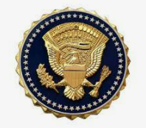

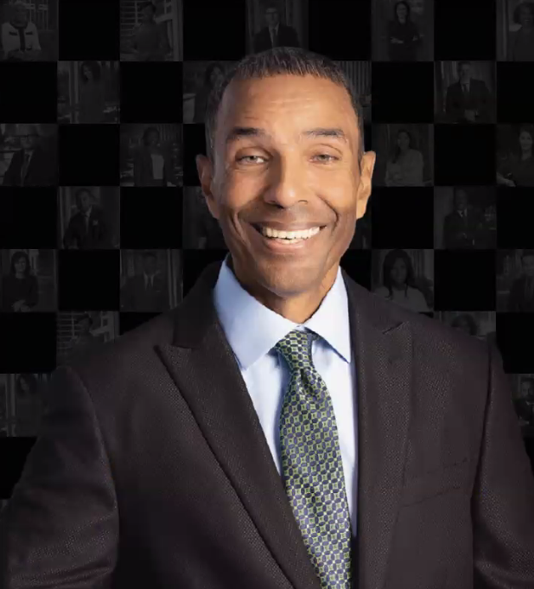

12/2021

**Thurman Smith**

PNC Community Development Banking