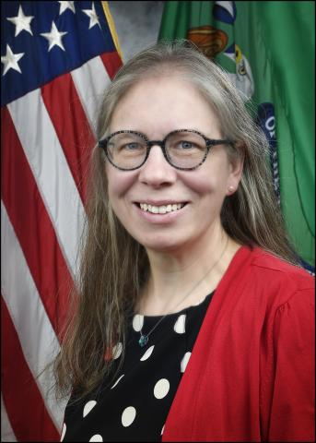

Shannon McKay
Program Manager, Financial Strategies and Research Unit

U.S. Department of the Treasury
Community Development Financial Institutions Fund

Shannon McKay is currently the Program Manager and Research Analyst in the Financial Strategies and Research Unit at the CDFI Fund. She has been with the CDFI Fund since 2019 where her portfolio has included managing the data collection, cleaning and report development of the Fund's Annual Certification and Data Collection (ACR) report, as well as supporting other research initiatives.

