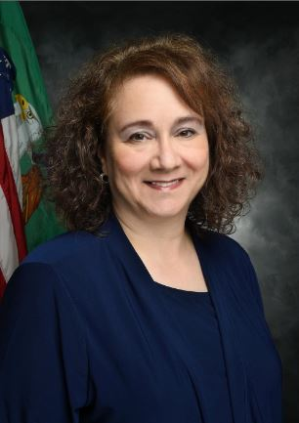

Marcia Sigal
Deputy Director, Policy and Programs

U.S. Department of the Treasury
Community Development Financial Institutions Fund

Marcia Sigal is the Deputy Director for Policy and Programs for the CDFI Fund, where she oversees the efforts of all of the CDFI Fund’s award programs in support of the CDFI Fund’s strategic vision. She previously served as the Program Manager of the Capital Magnet Fund. Prior to joining the CDFI Fund, Ms. Sigal was the Director of the Program Policy Division for the Office of Affordable Housing Programs in the U.S. Department of Housing and Urban Development. Ms. Sigal’s expertise as a community development policy analyst and innovator served her well as the Director of Community and Economic Development at the Council of State Community Development Agencies, an Affordable Housing Policy Analyst for the National Association of Housing and Redevelopment Officials (NAHRO), and Management Analyst at the Fairfax, VA Department of Housing and Community Development. In these roles, Ms. Sigal has shaped national outcome measurement metrics for community development programs, designed and launched new community development and affordable housing policies and programs, and developed capacity building and technical assistance programs for non-profit organizations as well as state and local governments. She has a Master’s Degree in City Planning from the Massachusetts Institute of Technology and attended Cornell University, where she studied community services and social work.

