John Moon

Senior Vice President
Sustainability Philanthropy Leader
Institute for Sustainable Finance
Wells Fargo & Company
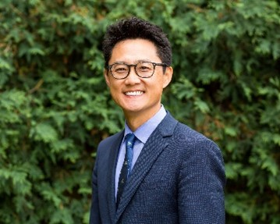
John Moon is Senior Vice President Sustainability Philanthropy Leader at Wells Fargo where he leads grant-making to scale sustainable finance toward an equitable climate transition. He has extensive public and private sector experience, focused on the intersection of racial equity, investments, climate, and health including work at the Federal Reserve, Living Cities, Municipal Government, and Fleetbank. A core focus has been how the built environment/communities are key levers to produce transformative change that improves economic mobility, resilience, and reduced inequality.

John has helped to lead national cross-sector initiatives in partnership with philanthropy, social impact investors, community-based organizations, and government to tackle complex social challenges holistically with a wide range of stakeholders and sectors. He also serves on a number of regional and national advisory groups. John graduated from UCLA and Harvard University’s Kennedy School of Government.

