Financial Institutions Panel – 2023

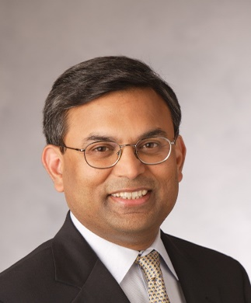
MODERATOR
Saurabh Narain
President and Chief Executive of National Community Investment Fund
Saurabh joined NCIF in 2003, and, under his leadership, the fund has become the largest equity investor (in numbers) in CDFI Banks in the country, grown assets under management to $228 million (including $203 million in NMTC allocations) and pioneered the development of NCIF’s Social Performance Metrics.
He is involved in policy and advocacy for the industry through his board positions in the CDFI Coalition(link is external) and memberships with the Federal Reserve Board’s Consumer Advisory Council (2008-10) and the Minority Depository Institutions Advisory Council of the Officer of Thrift Supervision (2009-11). NCIF is also a member of the Investors Council of the Global Impact Investing Network and the Strategy and Adoption Committee of the Impact Rating and Investing System led by the Rockefeller Foundation.
Prior to NCIF, Saurabh has extensive experience in capital markets and risk management having worked at Bank of America for almost 17 years, based in Asia and the US. Towards the end of his tenure in Hong Kong, he was Head of Marketing, Non-Japan Asia for Global Derivative Products. He has done business in almost 10 countries in Asia/US dealing with financial institutions, global multinational corporations and governments.
He is interested in inclusive finance and the microfinance movement in India. He is a member of the Steering Committee of the Professional Risk Managers’ International Association, Chicago Chapter and is a regular speaker in industry conferences. He is the current Treasurer of the CDFI Coalition.
Saurabh is a graduate of the ABA Graduate Stonier School of Banking (2007), and holds an MBA from Indian Institute of Management in Ahmedabad (1985), and a Bachelors of Arts (Honors) in Economics from St. Stephens College, University of Delhi (1983), India.

Jessel Amin, Executive Director, Community Development Banking, JPMorgan Chase

Jessel Amin is a Senior Commercial Banker in the Community Development Banking group at JPMorgan Chase where she leads the team’s East Coast CDFI lending strategy. Her work includes structuring holistic banking and credit solutions to meet the evolving needs of her CDFI clients.

Prior to joining JPMorgan Chase, Jessel was with Capital Impact Partners where she served as the Senior Manager of Capital Markets and Investments. Previously, she held roles as Director of Fixed Income Trading Operations at Morgan Stanley and as an analyst with Deutsche Bank.

Jessel graduated with an MBA from the Yale School of Management and a bachelor’s degree in finance and psychology from the University of Florida. Jessel is on the board of the Washington Area Community Loan Fund and the Chair of the Women Impact Investing Network. Jessel is passionate about promoting innovative capital solutions to work toward a more inclusive economy with shared prosperity for all.

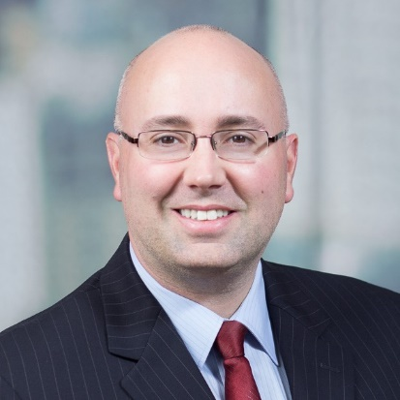

Sean Birney, Senior Vice President and Director of the Specialty Finance team, US Bank CDC
Sean Birney is Senior Vice President and Director of the Specialty Finance team within U.S. Bank’s Community Development Corporation, a $30 billion national business that finances community development projects and organizations in underserved markets throughout the United States. Sean leads a 9-person team responsible for originating and managing a $1 Billion loan and investment portfolio to Community Development Financial Institutions (CDFIs), Low-Income Housing Tax Credit Syndicators, and New Markets Tax Credit Sponsors.
Sean possesses over 20 years of experience in the community development and commercial real estate industries. Sean has experience lending to CDFIs and other community development organizations, as well as experience with direct project-based lending and NMTC-related project financing. Sean is knowledgeable about a wide variety of programmatic areas, including the affordable housing, charter school, healthcare, and healthy food sectors.
Prior to joining U.S. Bank, Sean was a Vice President for JPMorgan Chase’s Community Development Banking department, where he similarly was responsible for originating and managing a portfolio of community development loans. Sean has also worked previously for HSBC’s Community Development department, Prudential’s Impact Investments team, and Prudential’s commercial real estate team.
Complementing his relationship management work, Sean has served on loan and governance committees for numerous not-for-profit corporations, including Local Initiatives Support Corporation, Reinvestment Fund, Community Housing Capital, and Primary Care Development Corporation. Sean has participated in many industry working groups and expert panels, for organizations such as the Urban Institute and Global Impact Investing Network. Sean has also presented at numerous industry conferences, including Opportunity Finance Network, CDFI Coalition, and the Federal Reserve Bank Interagency Conference.
Sean received a B.A. in Economics and International Relations from Bucknell University, and an M.B.A. in Finance from Rutgers Business School.

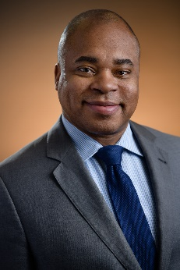

Amir Kirkwood, President and CEO of VCC Social Enterprises
As President and CEO, Amir Kirkwood leads VCC Social Enterprises (VCCSE) in its mission to promote an enhanced quality of life for the communities the organization serves. Amir has more than 20 years of banking and economic development finance experience. Prior to joining VCCSE, he served Opportunity Finance Network as Chief Investment and Network Officer. Amir was also responsible for management of all membership related operations including investment portfolio management, membership services, peer learning and programs and research. Amir helped the firm raise capital to support long term financing needs of the CDFI industry and was responsible for management of OFN’s $900 million of investments in CDFIs. He was a member of the Investment Committee and Credit Review Committee where he assisted the firm in risk and portfolio management.
Prior to OFN, Amir was First Vice President, Business Development where he was responsible for originations supporting Amalgamated Bank’s mission and impact banking goals. Internally, Amir worked across departments to develop Amalgamated Bank’s first Board approved credit policy for mission lending. Prior to Amalgamated Bank, Amir served as Partner at Next Street, playing various roles to support business development and client management, with a focus on financial services and financial intermediaries. Before Next Street, Amir was a Director in Citigroup’s Municipal Securities Division working as a relationship banker for Citi Community Capital. He managed origination with municipal agencies, CDFIs, intermediary lenders, Community Development Corporations, and nonprofits within target markets across the United States.
Amir is actively engaged in several volunteer activities that support community and economic development. He sits on several boards, including the Upper Manhattan Empowerment Zone, Hot Bread Kitchen, ROC USA, Pacific Community Ventures, and the Community Fund Board for Habitat for Humanity New York. Amir holds a B.A. in Political Science from Aurora University and completed graduate studies in economic policy management at Columbia University.

Thurman “Tony” Smith
Senior Vice President and Territory Executive, PNC Community Development Banking
Tony recently serves as Community Development Territory Executive for the Southeastern United States. Under his leadership, the bank closed one its earliest Opportunity Zone workforce housing developments in Sheboygan, WI. In Chicago, his team was the lead investor on the New Market Tax Credit enabled Englewood Whole Foods brining a national grocer to a food desert and the Opportunity Zone enabled Ogden Commons development which houses Mt. Sinai’s community health practice in West Lawndale, the TIF enabled Local Market grocer in South Shore and Pierce House in Humboldt Park which secures housing and support services for the homeless.
Through the pandemic, Tony launched the bank’s PPP liquidity Facility program, which offered more than $70 million in PRI’s to CDFI to enable delivery of PPP loans to very small businesses. He also served as a co-chair of the Chicago Inclusionary Housing Task Force which was established to frame the city’s affordable housing policy. He sits on several boards, including Institute Capita (A Durham NC based CDFI), the Cook County Land Bank Authority and the University of Chicago Community Accelerator. He previously served on the Executive Committee of Community Investment Corp (CDFI) and NHS Chicago.
He graduated Summa Cum Laude from Chicago State University where he was inducted in the school’s Academy of Distinguished Alumni. He completed his MBA at the University of Southern California. Tony also served in the Marine Corp. where he was assigned to the Presidential Helicopter Squadron as a White House Liaison Officer and is a recipient of the Presidential Service Medal.
He has more than 35 years of lending and credit experience, previouly led the commercial credit training program for a top 5 bank and has served as a tax credit consultant.

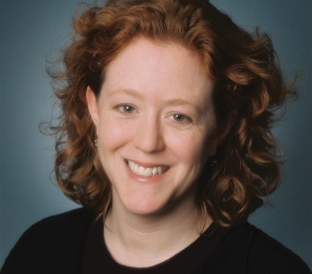
Megan Teare
Managing Director, Wells Fargo Community Lending and Investment, Minneapolis, Minnesota
Megan Teare has been working in the community development field for 25 years. She is currently a managing director with the Wells Fargo Community Lending and Investment group where she manages the program that provides enterprise-level capital to community development financial institutions (CDFIs), minority depository institutions (MDIs), and nonprofit housing developers. Megan also serves as a board member of Neighborworks Capital Corporation. Before joining Wells Fargo, she served as senior loan officer at the McAuley Institute and as a consultant to non-profit housing developers. She has an undergraduate degree in architectural history from Wesleyan University and a master’s degree in urban planning from the University of Virginia.

